**Image Classification**

**Big Data Analytics and Applications**

**Lab-4**

Classification Flow:



Data Set:

Four categories:

1)Road crossing

2)Human faces

3)Traffic lights

4)Walk paths

Extracting Image Descriptors:

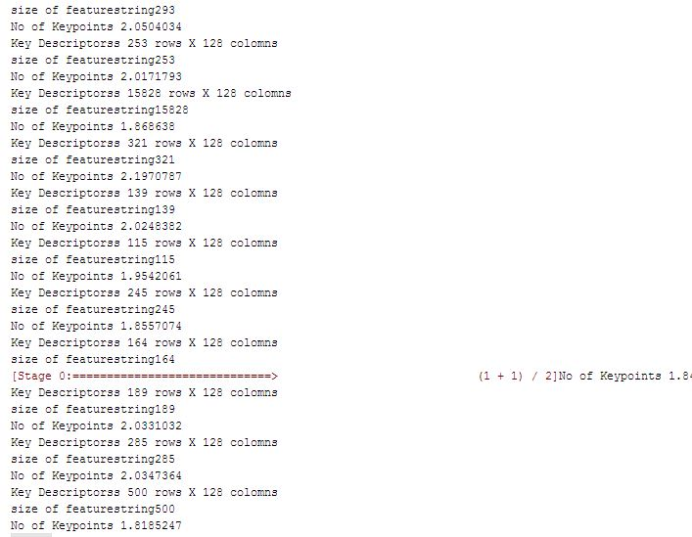

**KMeans Clustering and Histograms:**

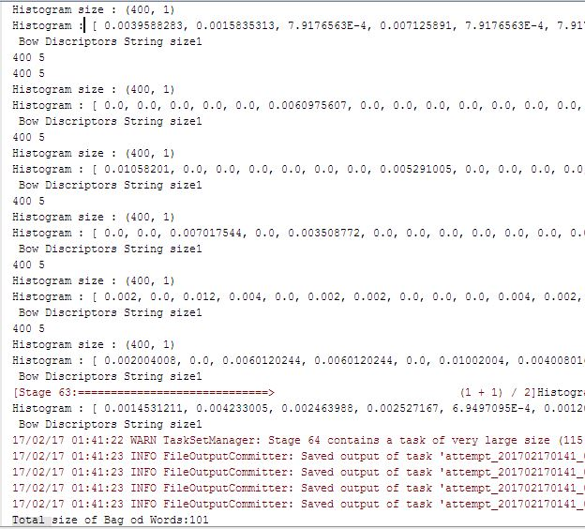

**Finding Best Parameters for Decision tree:**

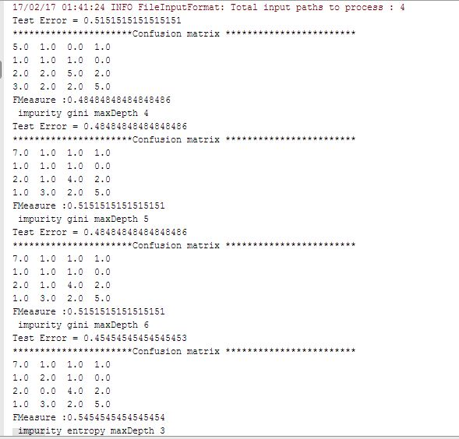

**Confusion Matrix after Testing:**

